To: Prof. Richard Wolff

From: Sam Harkness

Regarding: Network Design Lab Report

Date: 7 October 2013

**Summary**:

The objective of this lab is to demonstrate the basics of designing a network, taking into consideration the users, services, and locations of the hosts.

For this exercise, 4 different scenarios were created using the same basic network topology.

1. SimpleNetwork: 4 different LAN subnets – Engineerings, E-Commerce, Sales, and Research – of 10 workstations each are connected to three central servers – Web, File, and Database – via 100BaseT Ethernet. Inside each subnet, the subnets use 10BaseT. The network has 0% background utilization.
2. BusyNetwork: The same topology as SimpleNetwork, but now with 99% background utilization of the 100BaseT network.
3. Q3_OneServer: The Web, File, and Database servers are replaced by a single server, and the 100BaseT network has 99% background utilization.
4. Q4_FasterNetwork: The network between the subnets has been upgraded to use 10Gbps Ethernet, and the subnets are now wired for 100BaseT.

**Question 1:**

We collected 5 different statistics across SimpleNetwork and BusyNetwork, displayed in the 5 figures below. These statistics were chosen because of their relevance to the users (Email, Web Browsing, File Transfers, and Printing). Despite the 99% background utilization of BusyNetwork, the only area in which a user could potentially notice some delay is use of HTTP (Web Browsing). Every other collected statistic has differences less than 1/100th of a second.

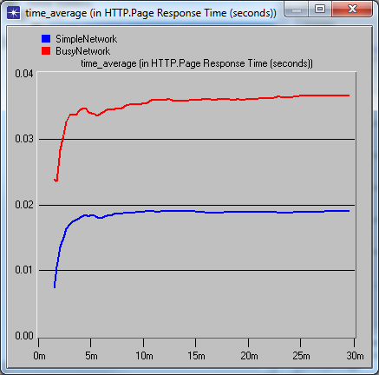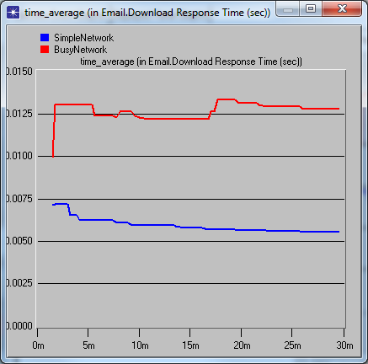

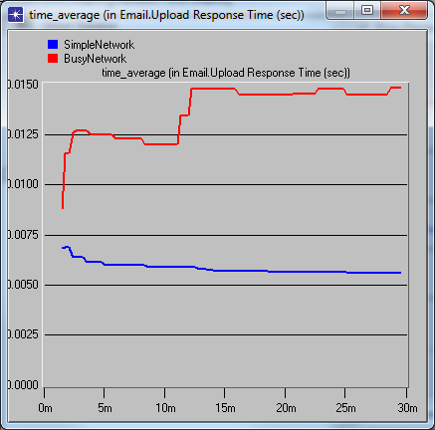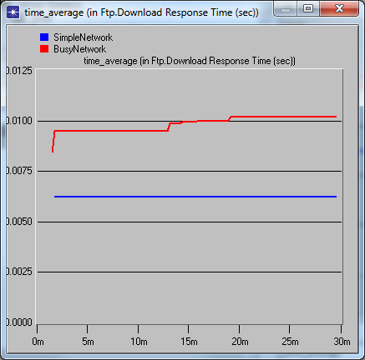

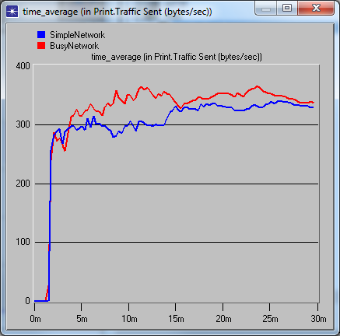

**Question 2:**

As you can see in the figure below, The CPUs of the servers are barely utilized at all. It is important to note that these servers do not model background utilization of the CPU at all, which could theoretically account for the remaining CPU utilization.

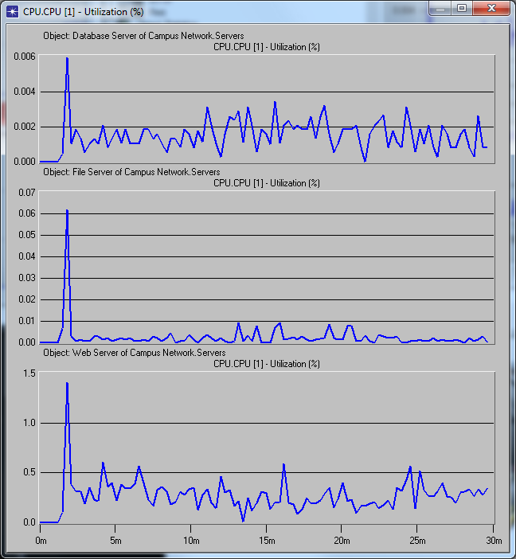

**Question 3:**

As you can see in the figure below, even combining all 3 servers into one still does not even reach 2% utilization on the CPU. The function below is the sum of the three previous utilization signals.

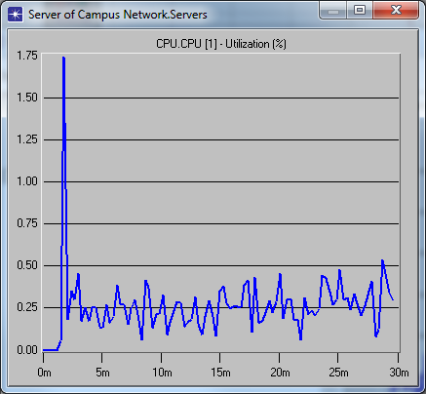

**Question 4:**

In the figure below, you can see FasterNetwork handles the increased traffic much better than BusyNetwork, and even outperforms SimpleNetwork despite the 99% utilization.

